Archim2 Conversion Guide

For the Lulzbot TAZ 6

v1.0   
1/18/2020

Contents

Purpose 2

Where to Buy an Archim2 Board? 2

Electrical 3

Limit Switch Extensions 4

5V AUX Connections 5

Replace Terminal Plug with 45 Degree Style 6

Connector for GPIO Header 7

Connecting the Bed Level Probe 8

LCD Screen Wiring 9

Mechanical 10

Heatsink Mount 10

Heatsink Bar 11

Thermal Pads 11

Configuration 12

Firmware 12

APPENDIX 13

Digikey Parts BOM 13

Wiring Diagram 14

Aluminum Heatsink Mechanical Drawing 15

Included in the root directory is a spreadsheet that outlines the parts used, the STL model of the printed heatsink mount (both [stock](http://download.lulzbot.com/TAZ/TAZ_Pro/v1.0.7/production_parts/printed_parts/heatsink_mount/) and modified as described in the Mechanical Section), and the [design drawing for the heatsink from Lulzbot](http://download.lulzbot.com/TAZ/TAZ_Pro/v1.0.7/production_parts/machined_parts/board_heatsink/Archim_board_heatsink.pdf). This information, as well as a wiring diagram are in the Appendix.

**Disclaimer:** You do this work at your own risk. Your warranty will likely be voided by doing this. It is up to the implementer if the advantages of doing this work outweigh the risks. Wiring, crimping, and soldering is involved.

Purpose

The purpose of the guide is to assist users with a Lulzbot TAZ6 3d Printer in the conversion steps from the stock 8-bit, 16MHz RAMBo board to the 32-bit, 84MHz Archim2 board that is used in the Lulzbot TAZ Pro. Provided are the steps that I took to complete my conversion.

**Why would you want to do this?** There are a few primary reasons to do this conversion. First, the Archim2 uses a much faster microprocessor that has many more resources and native USB support. This allows for GCODE to be parsed and executed faster resulting in smoother movement during complicated geometries that require many lines to be processed and executed quickly (like circles that are made up of a great deal of line segments). The Archim2 also utilizes Trinamic TMC2130 stepper motor controllers which have several improvements and advantages over the Allegro A4982 motor controllers used on the RAMBo boards, including silent operation. Seriously, unless you are watching the printer, you can’t hear it! Also, with alternate firmware like Klipper can take advantage of the native USB to send instructions very fast.

**PLEASE READ THIS ENTIRE DOCUMENT BEFORE ATTEMPTING THIS TO ENSURE THAT YOU HAVE PURCHASED AND/OR PRINTED EVERYTHING YOU WILL NEED!**

# Where to Buy an Archim2 Board?

The Archim2 is made by UltiMachine and can be purchased from their site [here](https://ultimachine.com/products/archim2?variant=13739792466029):  
<https://ultimachine.com/products/archim2?variant=13739792466029>

Since this board will be replacing the RAMBo, one only needs to buy the “Assembled Circuit Board ONLY” (select under Kit Options). The NOTE on the bottom of the product page states:

“***NOTE:*** If purchasing this board as a replacement for one received in another distributor's printer kit, please "Add a note to your order" ("notes" located in shopping cart view) prior to checkout regarding your printer's name/version/distributor details. The controller ***may*** require some adjustments for printer compatibility. Thank you!”

So, I went ahead and told them that this board was going into a Lulzbot TAZ6 and had no issues with the configuration I was sent. Note that the images on the site show the Archim2 2.1a, however, they are shipping the 2.2b. I have no clue what the difference is as nothing they have online (including the wiki) mention the 2.2b. I assume it is a trivial change (probably BOM related).

# Electrical

This section covered the electrical considerations for the conversion. The images below outline the connections that are referenced and the wiring that was done.

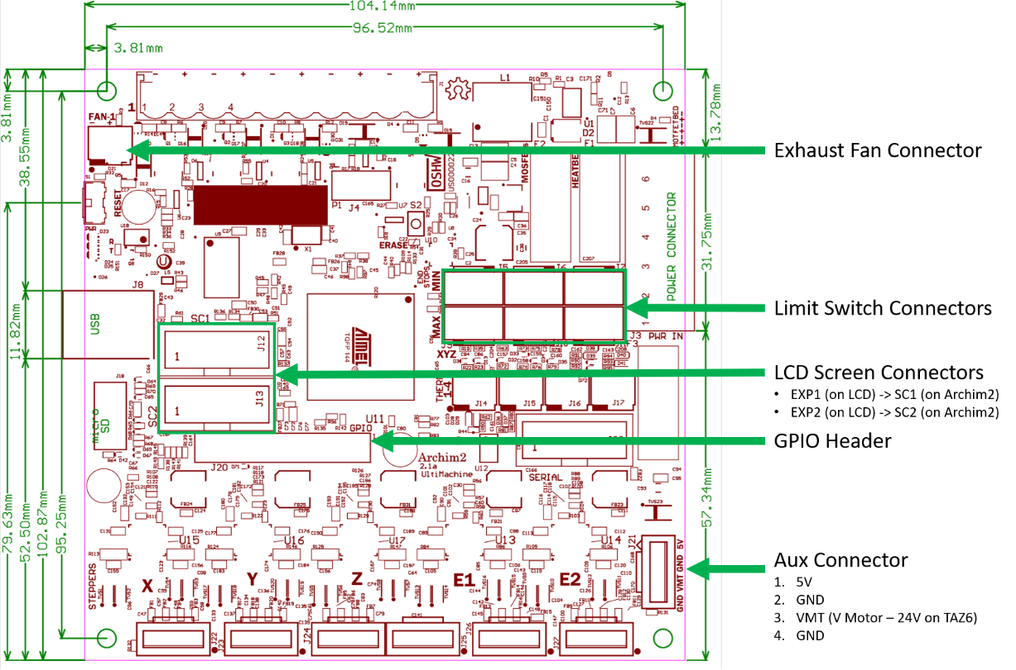

Archim2 v2.2b (current board revision being shipped). [Schematics](https://github.com/ultimachine/Archim/blob/c68ed12ccc4da3c50be3b65031d0f8b64b89efce/Project%20Outputs/Archim2_2.1a_Schematic.PDF) can be found on the [reprap wiki](https://reprap.org/wiki/Archim2).

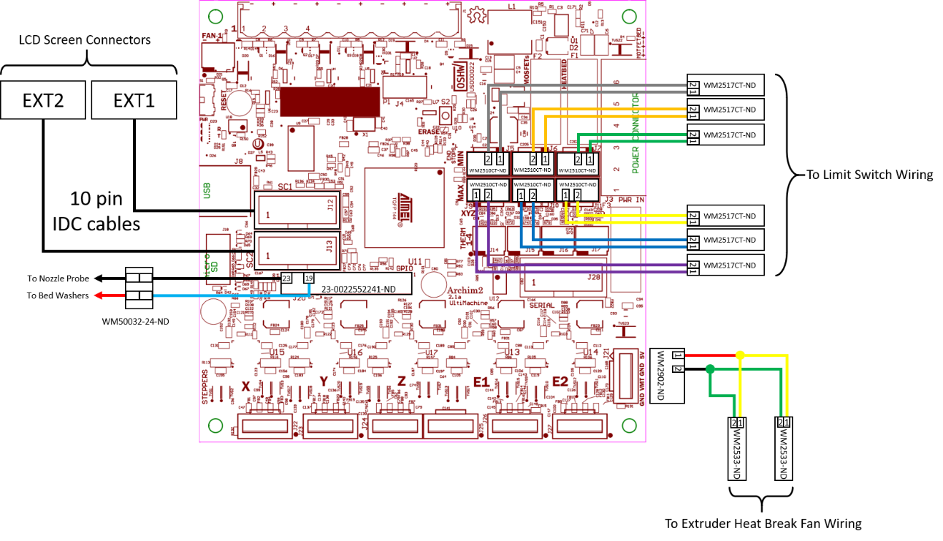

Wiring diagram to existing wire harness. See Appendix or included spreadsheet for Digikey BOM and enlarged image. Note that all connections not shown here can be directly move over from the RAMBo.

## Limit Switch Extensions

Lulzbot optimized cable lengths in their harnesses. As a result, some connections do not reach their intended target on the Archim2. The limit switches do not reach their new locations so extensions need to be made. This does not need to be done to all the limit switch connections as a few can be made to reach the Archim2 board, however, they make the wires tight. I just made an extension for all of them.

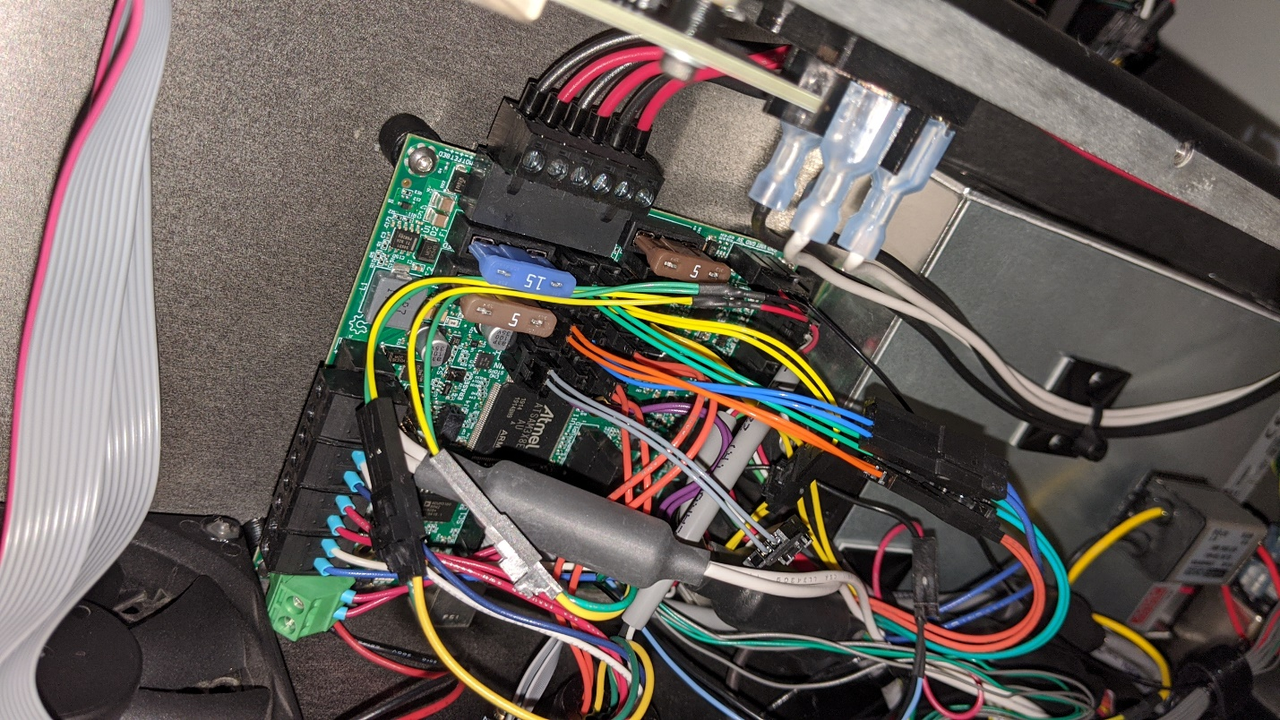

Limit Switch Connectors

Extensions

Original Cable Harness

## 5V AUX Connections

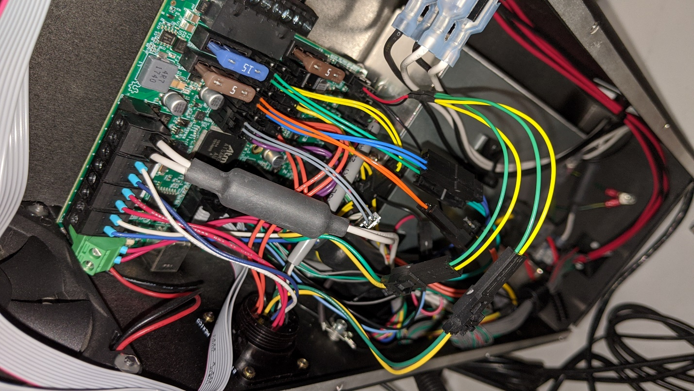

AUX Power Connector

(5V and 24V available)

5V “Y” Cable

Original 5V Cable Harness  
(Green and Yellow wires)

The extruder heat break fan(s) need 5V to run. The Archim2 uses a 4 pin AUX connector that has 5V and VMT (supplied motor voltage = 24V on TAZ6). I wired the 5V supply (bottom right) to a “Y” cable that provides 5V to both of the extruder harnesses. Refer to the board layout on page 3 and wiring diagram in Appendix.

The stock wiring harness uses green and yellow wires for the fan 5V supply. The yellow wire is the 5V and green is ground. I wanted to keep both extrtuder harnesses wired up, so I tied both yellow wires together and both green wires together. This makes up the “Y” connection.

## Replace Terminal Plug with 45 Degree Style

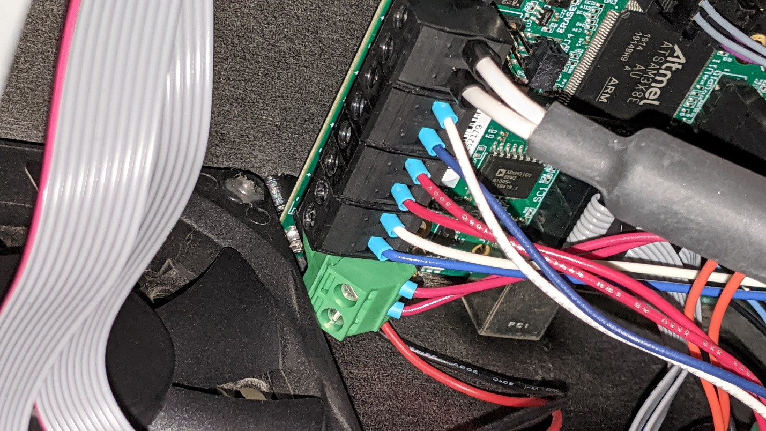

Replace the stock 90 degree black terminal block with one that allows for a 45 degree interface to clear the exhaust fan (green terminal plug in image). The terminal strip on the top of the Archim2 is right next to the edge of the board eliminating the clearance that the RAMBo board had.

## Connector for GPIO Header

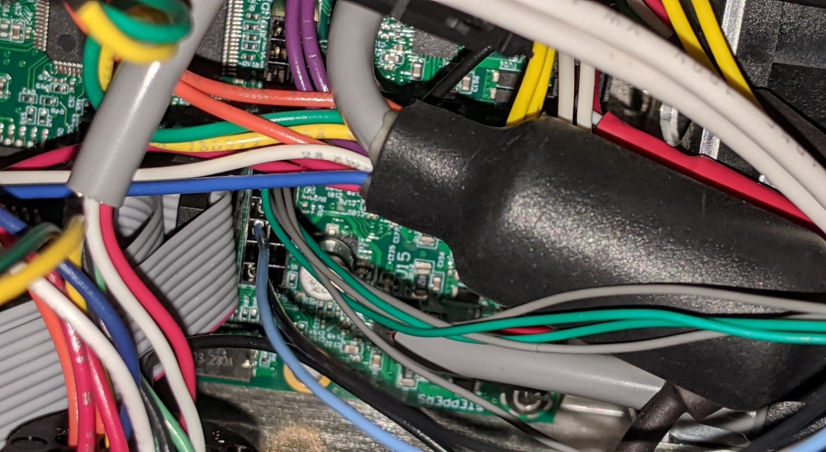

GPIO Bed Level Signal Connector

(Blue and Black wires used for bed probe in my setup)

Use the GPIO header (J20) to wire in the bed leveling probe. The TAZ6 uses a 5V pulled up signal on the bed washers that gets grounded by the nozzle when contact is made using the RAMBo board. [The RAMBo board had a 100nF capacitor wired between the signal and ground pins for this.](https://ohai.lulzbot.com/project/rambo_patch/taz-6/) I did not do that and have yet to have a problem with bed leveling. The Archim2 operates on 3.3V, thus we will now have a 3.3V pulled up signal on the bed washers. I used pin 19 on J20 (which routes to PB13 on the microcontroller) and pin 23 on J20 which is ground. See wire diagram in Appendix.

## Connecting the Bed Level Probe

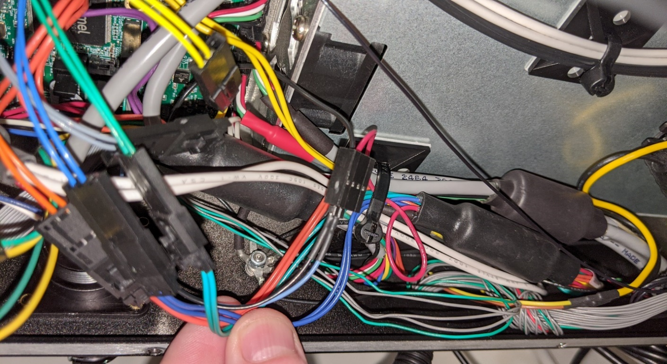

Bed Level Connector to Wire Harness

(Blue and Black wires used for bed probe in my setup)

With the GPIO connector on the header, wire one of the GPIO pins and GND to the connector housing on the wiring harness. You have some flexibility here and can use any GPIO pin for this. On the TAZ6 wiring harness, the **red** wire is the pulled up 3.3V signal that gets routed to the bed washers, and the **black** is ground that runs to the heater block. For my installation, I wired the red wire to the blue signal seen above which goes to pin 19 on the GPIO header (J20) and my firmware was set to match. The black wire is connected to pin 23 on J20, which is ground. The blue and black wires connected to the GPIO connector are soldered to a pair of header pins that connect to the bed level probe connector housing assembled into the TAZ6 harness. See wire diagram in Appendix.

**Note:** The RAMBo board operated on 5V, which means that the probe signal voltage was also 5V. The Archim2 operates at 3.3V, so the prove signal will also be 3.3V. This does not affect anything, but it is important to know that 5V signals should not be directly read by the microprocessor unless the pin is 5V tolerant – which is out of the scope of this guide.

## LCD Screen Wiring

The connectors in the Archim2 board that support the stock TAZ6 LCD screen are labeled SC1 and SC2. They are the same pinout as the RAMBo 1.4 PCB. Thus, if your TAZ6 came with the 1.4 version of the RAMBo board, you can just connect EXT1 and EXT2 to SC1 and SC2 respectively*. If your TAZ6 came with the older RAMBo 1.3L (like mine did) you will have to get a set of 10 pin, 0.1” pitch IDC cables. I got some 30cm long cables that allow me to connect the LCD to the Archim2 while routing them along the roof of the case and not impede airflow.

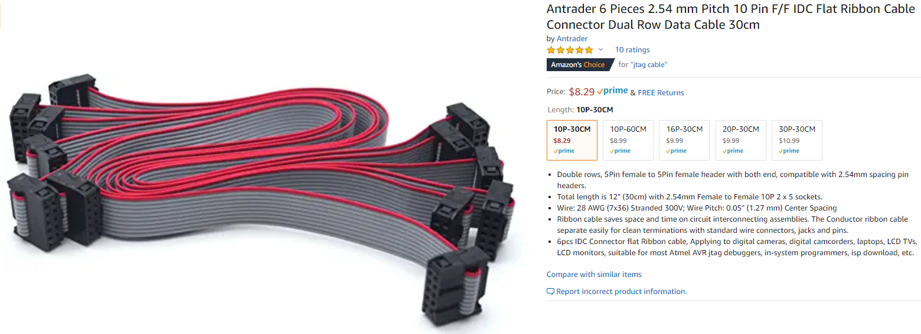

**\*Note:** I am unsure if the length of the stock 10 pin cables that come with the RAMBo 1.4 version of the TAZ6 are long enough to reach the LCD connectors on the Archim2. Even if they are, then might not be ideal for airflow.

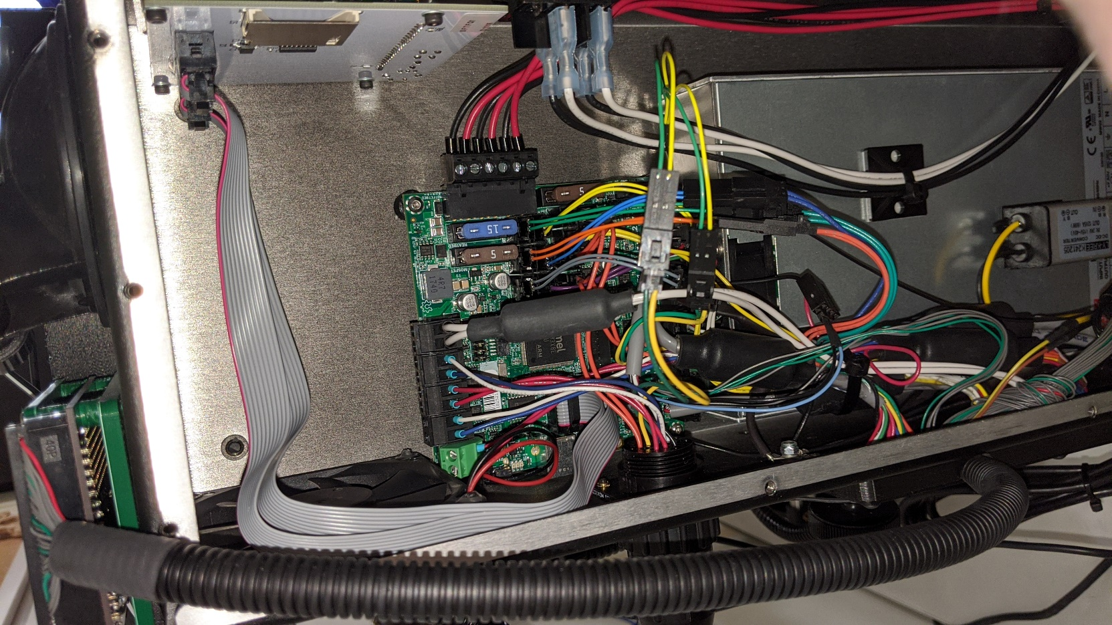

# Mechanical

This section covers the mechanical considerations for the conversion, which is based on the [assembly of the Lulzbot TAZ Pro.](https://ohai.lulzbot.com/project/control-box-assembly/quiver/) The TAZ Pro also uses the Archim2 board and Lulzbot has installed a heatsink bar that allows for a heat path from the stepper controllers to the control box housing. The heatsink bar is made from aluminum and sandwiched between two sheets of thermal heat pads. The thermal heat pads allow for optimal heat transfer while maintaining electrical isolation between the board and the case.

## Heatsink Mount

The heatsink stack up is held in place with the use of a 3D printed mount that registers itself using the PCB standoffs. The STL of the stock heatsink mount is provided, as well as a modified version that provides for a longer heatsink bar. The stock mount only supports a heatsink bar that sits under the X, Y, and Z stepper controllers. I am not sure why this design excludes the E0 and E1 stepper controllers, so I modified the mount to allow for a longer heatsink bar that sits under all 5 stepper controllers, which is also included in this document. I used ABS incase it got warmer than expected. Didn’t want it sagging.

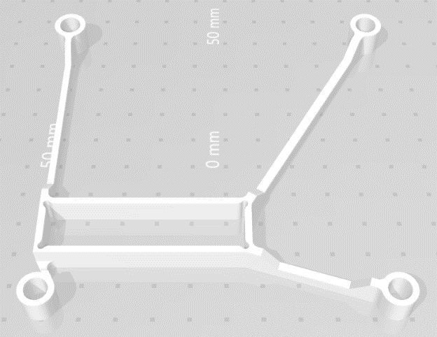 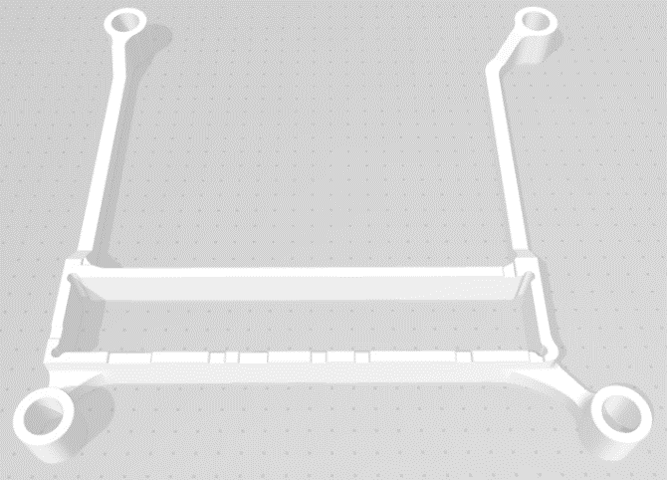  
Stock heatsink mount (only covers XYZ) Modified heatsink mount (covers all controllers)

## Heatsink Bar

The stock heatsink bar is 55mm long (refer to the included PDF). The modified heatsink bar is 85mm long and all other dimensions are the same as the stock heatsink bar. Please note that it is recommended to measure the height of the PCB standoffs in your printer. Since the height of these are not a critical dimension in the TAZ6, it is conservable that they may vary slightly between printer revisions and build lots. The standoff height dimension is an important factor in the thickness requirement of the aluminum heatsink. It needs to be sized such that the board applies slight compression of the thermal pads when screwed down so that the pads can conduct the heat, but not so much that the PCB gets aggressively bowed. See included PDF or Appendix.

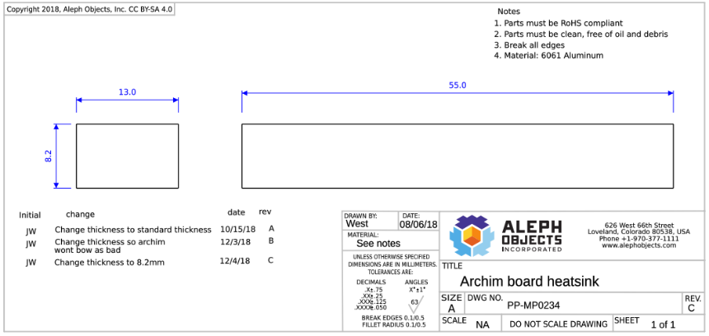

## Thermal Pads

For the thermal pads, I used Fujipoly thermal pads to interface the aluminum heatsink between the PCB and the case. This stuff isn’t cheap, but it has great thermal conductivity and electrical isolation characteristics. I used 0.5 mm thick material on the bottom (where the heatsink interfaces with the case) and 1.0mm thick material on the top (where the heatsink interfaces with the PCB. The reasoning for this was to allow for easier deformation of the material against the more fragile PCB and the slightly thicker material allowed for this.

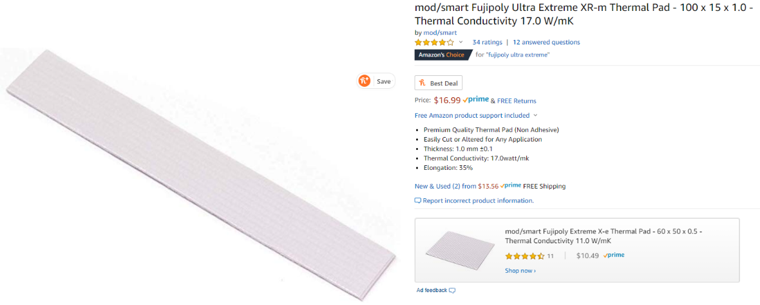

# Configuration

After completing all the electrical and mechanical modifications and the board is fully installed - **double check all electrical connections! All the connections (except the bed level probe and AUX 5V for the heat break fans) are a direct swap, pin-for-pin from the RAMBo board.** This includes power plugs and FET controlled outputs. The pin that was selected as the bed level probe signal will need to be defined as an **active low**, **pulled-up** signal in the firmware as the bed level probe pin. This means that the microprocessor on the Archim2 board will read 3.3V while the nozzle is not touching one of the bed washers and this condition will be interpreted as a **false** state. Once the nozzle touches one of the washers, a path to ground for the bed level signal will be created and the microprocessor will read 0V, which will be interpreted as a **true** state.

**Note:** Proceed with caution. Ensure that any pins that are used as signals (like the bed level probe) are defined properly using a pull-up resistor in the firmware (or externally if internal pull-ups are not supported, which I do not think is the case for the microcontroller used on the Archim2). If a pin is configured as an output and set high, grounding it could damage the microcontroller.

Other peripherals, such as filament sensors, lighting control, external fans, etc, can be wired to the GPIO header and written into the firmware as needed. Refer to the [Archim2 schematic](https://github.com/ultimachine/Archim/blob/c68ed12ccc4da3c50be3b65031d0f8b64b89efce/Project%20Outputs/Archim2_2.1a_Schematic.PDF) from the [reprap wiki](https://reprap.org/wiki/Archim2).

# Firmware

This could have multiple options, but below are the two that I think are best supported.

**Marlin Option:** If using Marlin is desired, [Drunken Octopus](https://github.com/marciot/drunken-octopus-marlin) states that this configuration is supported. I have not done this yet, but it seems like the best Marlin path. Thanks Marcio!

**Klipper Option:** I have created a [Klipper](https://github.com/KevinOConnor/klipper) configuration file for my TAZ6 Archim2 with Dual v3 extruder printer. It has all the configuration needed, including the probe pin defined on pin PB13 as a pulled-up, active low signal. I have been experimenting with this for a few months and have had no operational problems. I will soon add it to the Klipper repo so others can use it out of the box with Klipper!

**Disclaimer:** You do this work at your own risk. Your warranty will likely be voided by doing this. It is up to the implementer if the advantages of doing this work outweigh the risks. I have not run this configuration with Marlin firmware yet, so there may be other needed modifications if using that codebase, although I cannot think of any. I use Klipper firmware to un my printer currently and it allows for custom pin definition in a configuration file. This was done for the bed leveling probe using the GPIO header.

# APPENDIX

## Digikey Parts BOM

Below is the list of parts that are needed to complete the electrical work outlined in this document.

|  |  |  |  |  |  |
| --- | --- | --- | --- | --- | --- |
| **Index** | **Quantity** | **Part Number** | **Manufacturer Part Number** | **Description** | **Use** |
| 1 | 1 | WM2902-ND | 0050579404 | CONN HOUSING 4POS .100 W/LATCH | Aux Power connector for 5V to extruder heat break fan |
| 2 | 50 | WM2510CT-ND | 0016020086 | CONN SOCKET 22-24AWG CRIMP TIN | Female crimps for limit switch extensions and Aux power |
| 3 | 50 | WM2517CT-ND | 0016020107 | CONN PIN 22-24AWG CRIMP TIN | Male crimps for limit switch extensions |
| 4 | 6 | WM2901-ND | 0050579403 | CONN HOUSING 3POS .100 W/LATCH | Female connector for limit switch extensions |
| 5 | 6 | WM2534-ND | 0701070002 | CONN HOUSING MALE 3POS .100 | Male connector for limit switch extensions |
| 6 | 1 | 23-0022552241-ND | 0022552241 | CONN HOUSING 24POS .100 DUAL | GPIO connector housing block |
| 7 | 50 | WM14366CT-ND | 0700580086 | CONN SOCKET 22-24AWG CRIMP TIN | Crimps for GPIO housing block |
| 9 | 1 | 277-5963-ND | 1826283 | TERM BLOCK PLUG 2POS 5.08MM | 45 deg terminal plug to clear exhaust fan |
| 10 | 2 | WM2533-ND | 701070001 | CONN HOUSING MALE 2POS .100 | Male connector for 5V AUZ power to heat break fans |
| 11 | 1 | WM50032-24-ND | 22284242 | CONN HEADER VERT 24POS 2.54MM | Header pins to connect to bed level probe harness |

## Wiring Diagram

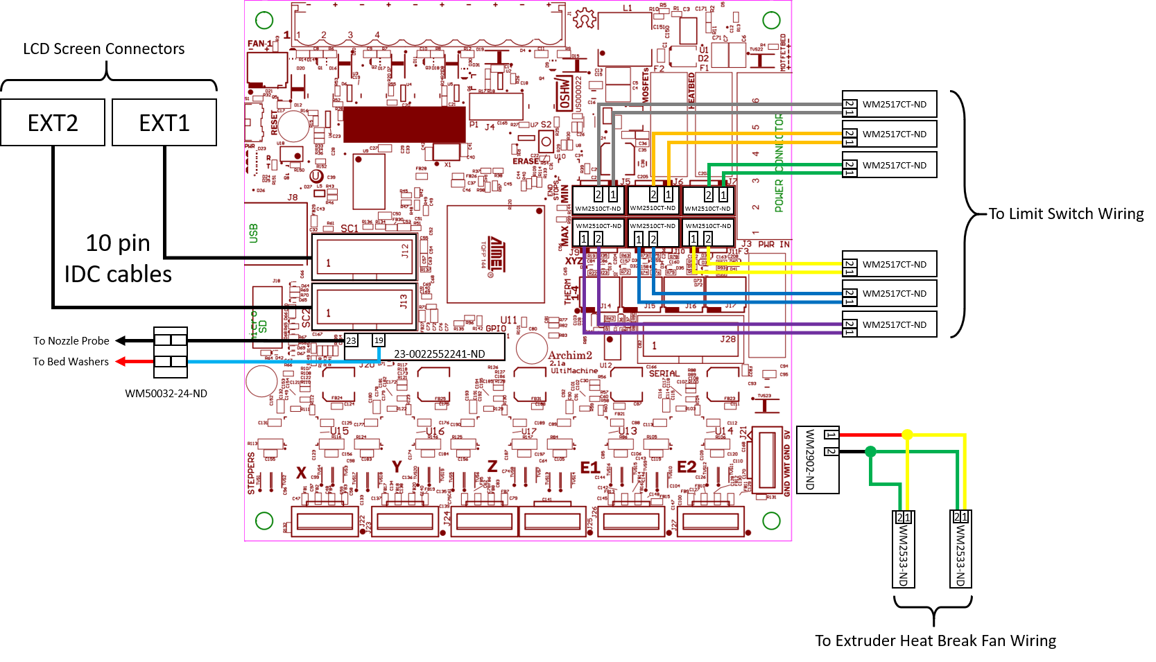

## Aluminum Heatsink Mechanical Drawing

